Practical No : 12
Q.1] Write a program to display Student’s details (name, roll no, marks) using a controller.

index.html :-
<!DOCTYPE html>
<html ng-app="myApp">
<head>
<title>Student Details</title>
<script src="https://ajax.googleapis.com/ajax/libs/angularjs/1.8.2/angular.min.js"></script>
</head>

<body>

<!-- Parent Controller -->
<div ng-controller="studentCtrl">
<h2>Student Information</h2>
<p>Name: {{name}}</p>

<!-- Child Controller -->
<div ng-controller="marksCtrl">
<p>Roll No: {{rollno}}</p>
<p>Marks: {{marks}}</p>
</div>
</div>

<script>
var app = angular.module("myApp", []);

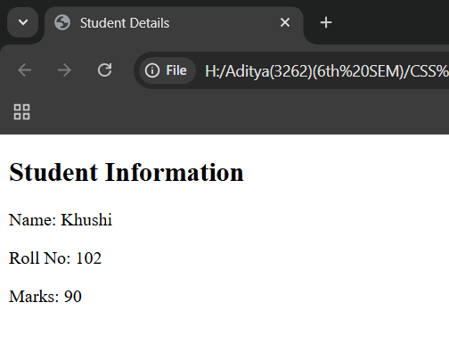
app.controller("studentCtrl", function($scope){
$scope.name = "Khushi";
});

app.controller("marksCtrl", function($scope){
$scope.rollno = 102;
$scope.marks = 90;
});
</script>

</body>
</html>

2. Write a program where one controller is nested inside another (Parent–Child).
Index2.html
<!DOCTYPE html>
<html ng-app="myApp">
<head>
<title>Parent Child Controller</title>
<script src="https://ajax.googleapis.com/ajax/libs/angularjs/1.8.2/angular.min.js"></script>
</head>

<body>

<div ng-controller="parentCtrl">
<h2>Company: {{company}}</h2>

<!-- Child Controller -->
<div ng-controller="childCtrl">
<h3>Employee: {{employee}}</h3>
<h3>Works In: {{company}}</h3>
</div>
</div>

<script>
var app = angular.module("myApp", []);

app.controller("parentCtrl", function($scope){
$scope.company = "Infosys";
});

app.controller("childCtrl", function($scope){
$scope.employee = "Vishal";
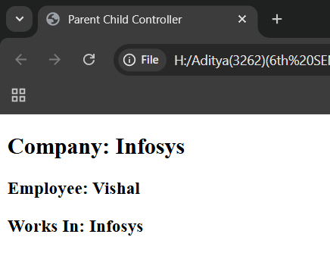
});
</script>

</body>
</html>

Output :-

